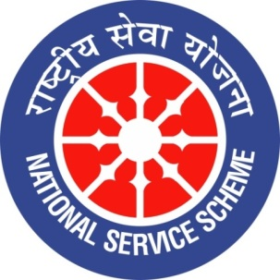
GUJARAT TECHNOLOGY UNIVERSITY
NATIONAL SERVICE SCHEME
Lukhdhirji Engineering College-Morbi
A Report on Tree Plantation on 17/7/2021 of L.E.College-Morbi

NSS Unit Name/College Name: L.E.College-Morbi
Event NAME: Tree Plantation
Event Date, Time and Location: 17/7/2021, 4:00 pm, Hostel campus
Brief Description of the Event:
As a part of Tree plantation-2021 drive by GTU, L.E.College has organized tree plantation program. The venue for said program is boy’s hostel campus of L.E.College. The event was organized under the motivation principal (Dr.) S.N.Pandya. (Prof.) K.F.Bhetariya, HOD applied mechanics department and tree lover, was maincoordinator of this program. Volunteers of NSS cell and NCC cell has worked hard for this program. Eminent guest were invited. Staff members from all departments have actively participated in this event. Total 30 trees were planted.
Major Outcomes of Event:
- New trees are planted
- Butification of campus
- Benifit to environment
Photographs of the Event:
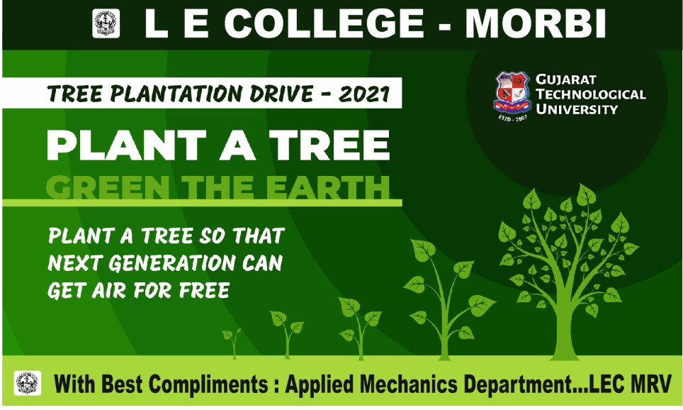

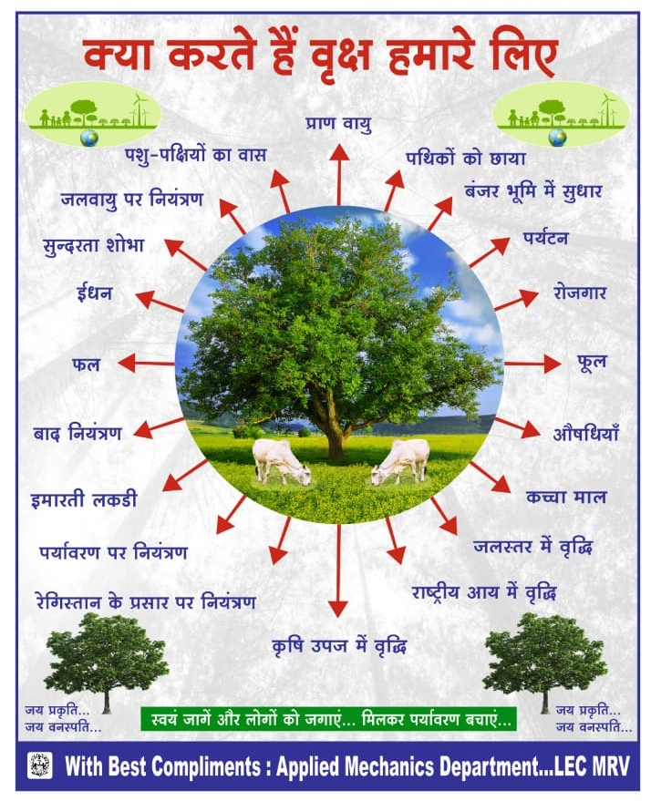
Flyer and banners of this event
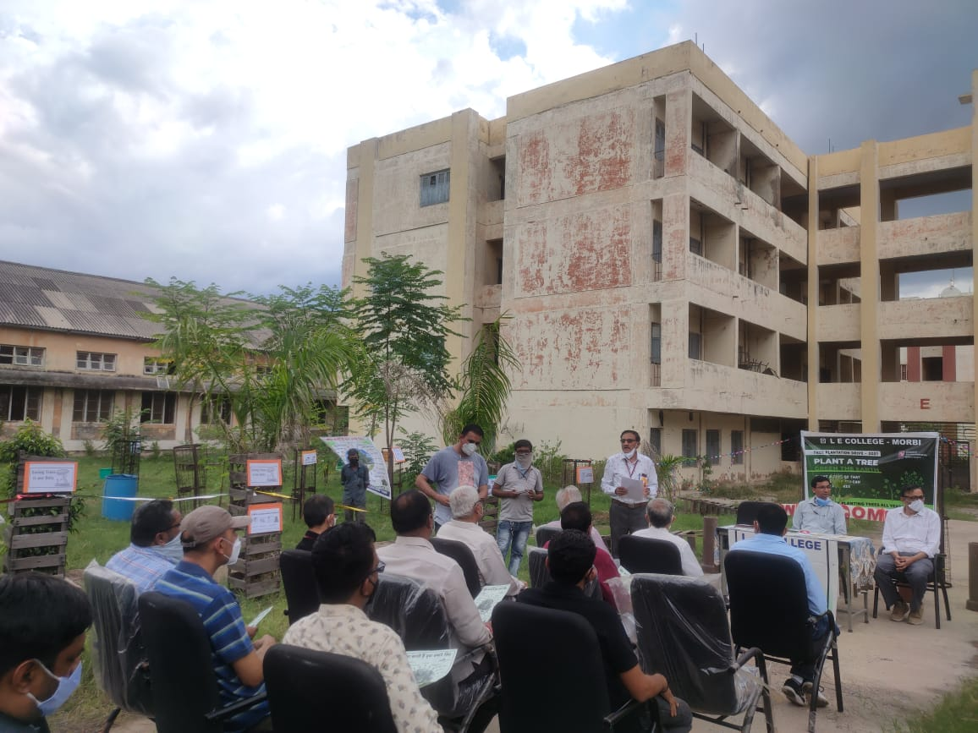

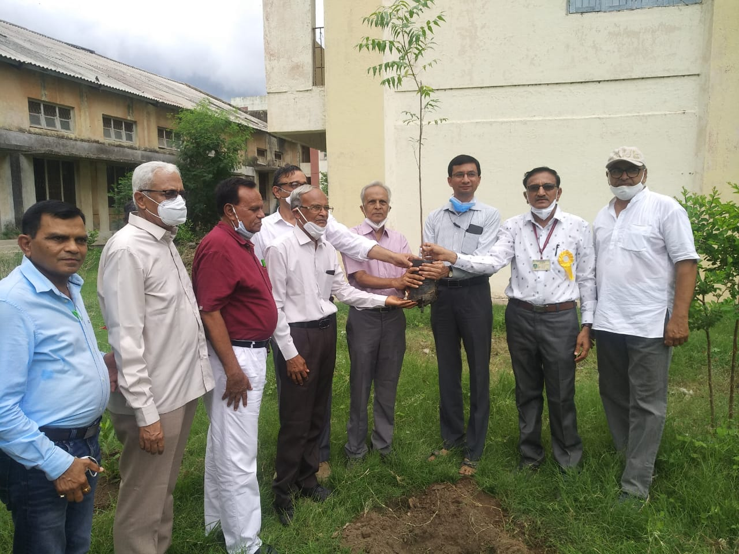

Blessings of Principal sir and invited guests
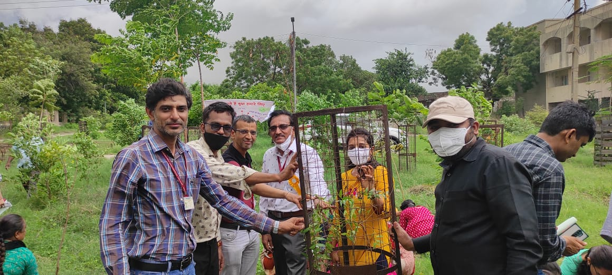
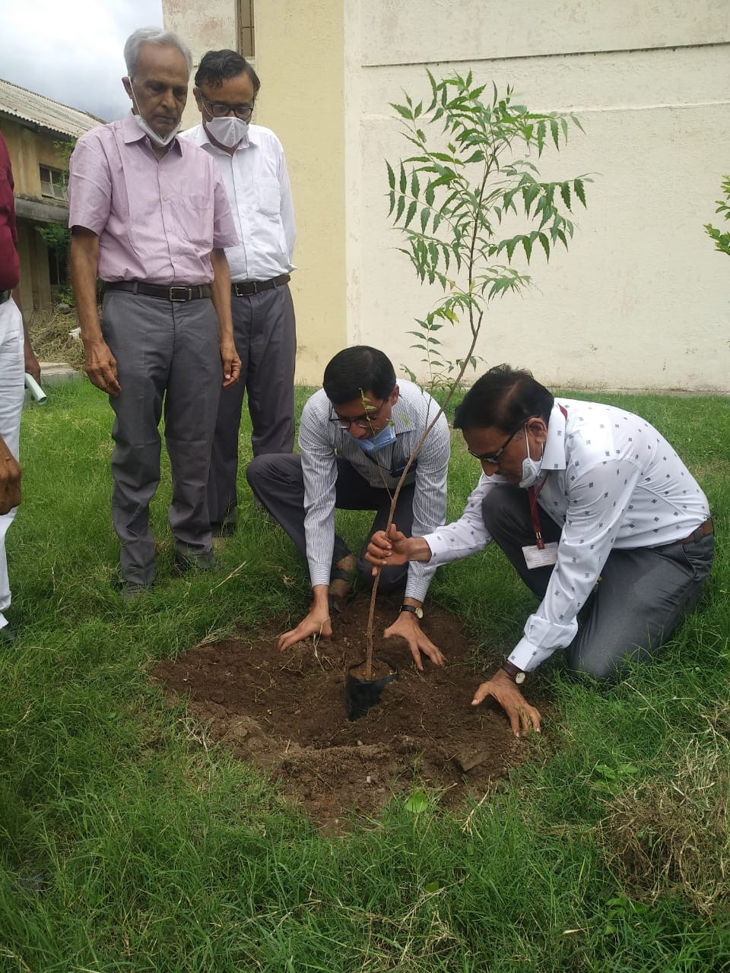

Tree plantation by faculty members

